**CROSS ZONE LOAD BALANCING**

Suppose we have a load balancer which balances the load across az.

Then there are two cases as shown below:

1.With cross zone load balancing

All the traffic is equally distriuted across the instances in the az.

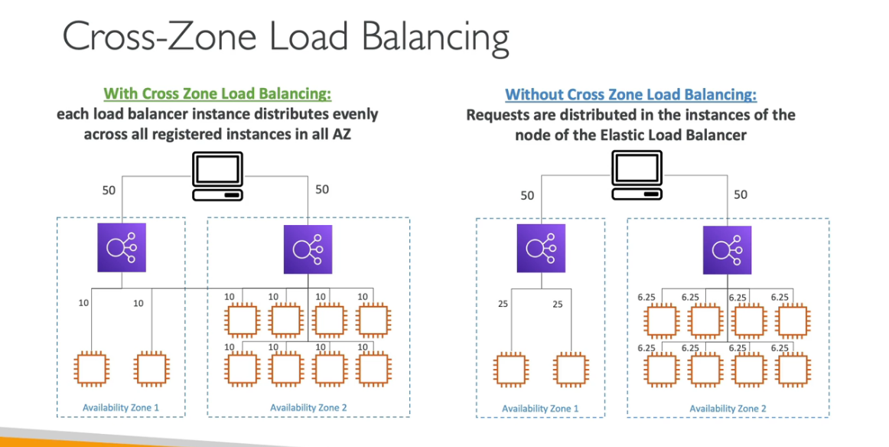

HANDS ON

Now we have created three load balancers as shown image below:

Now we can click on any load balancer and then go to the attributes section and enable or disable the cross zoen load balancing depending upon our requirement.

Imp:

When we have the case of an application load balancer then in that case the cross zone load balancing will by default be on and you will not be able to disable it from the load balancer so for that you will have to go to the target group and from there you need to edit the attributes.